

Class : 9 Subject : Mathematics

Chapter 11 - Constructions Excercise Ex. 11.2

Solution 1

The steps of construction for the required triangles are as follows:

**Step I:** Draw a line segment BC of 7 cm. At point B draw an angle of 75o sayhttp://images.topperlearning.com/topper/bookquestions/1089_4934c411dbc1a55c0b7875b3e0fc862a.pngXBC.

**Step II:** Cut a line segment BD = 13 cm (that is equal to AB + AC) from the ray BX.

**Step III:** Join DC and make an angle DCY equal to http://images.topperlearning.com/topper/bookquestions/1089_4934c411dbc1a55c0b7875b3e0fc862a.pngBDC

**Step IV:** Let CY intersects BX at A. http://images.topperlearning.com/topper/bookquestions/1089_ec7fd5b2b4109644a398eba4d25ebf00.pngABC is the required triangle.  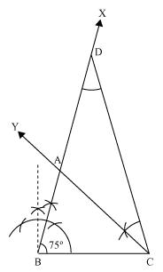

Solution 2

The steps of construction for the required triangles are as follows:  
**Step I:** Draw the line segment BC = 8 cm and at point B make an angle of 45o say http://images.topperlearning.com/topper/bookquestions/1090_4934c411dbc1a55c0b7875b3e0fc862a.pngXBC.       
**Step II:** Cut the line segment BD = 3.5 cm (equal to AB - AC) on ray BX.

**Step III:** Join DC and draw the perpendicular bisector PQ of DC.

**Step IV:** Let it intersect BX at point A. Join AC. http://images.topperlearning.com/topper/bookquestions/1090_ec7fd5b2b4109644a398eba4d25ebf00.pngABC is the required triangle.

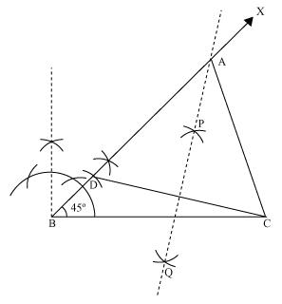

Solution 3

The steps of construction for the required triangles are as follows:  
**Step I:** Draw line segment QR of 6 cm. At point Q draw an angle of 60o say http://images.topperlearning.com/topper/bookquestions/1091_4934c411dbc1a55c0b7875b3e0fc862a.pngXQR.  
**Step II:** Cut a line segment QS of 2 cm from the line segment QT extended an opposite side of line segment XQ. (As PR> PQ and PR - PQ = 2cm). Join SR.  
**Step III:** Draw perpendicular bisector AB of line segment SR. Let it intersect QX at point P. Join PQ, PR. http://images.topperlearning.com/topper/bookquestions/1091_ec7fd5b2b4109644a398eba4d25ebf00.pngPQR is the required triangle.

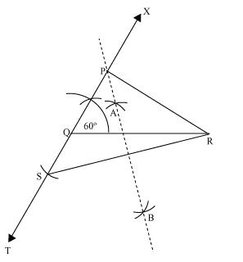

Solution 4

The steps of construction for the required triangles are as follows:

Step I: Draw a line segment AB of 11 cm.(As XY + YZ + ZX = 11 cm)

Step II: Construct an angle http://images.topperlearning.com/topper/bookquestions/1092_4934c411dbc1a55c0b7875b3e0fc862a.pngPAB of 30o at point A and an angle http://images.topperlearning.com/topper/bookquestions/1092_4934c411dbc1a55c0b7875b3e0fc862a.pngQBA of 90o at point B.

Step III: Bisect http://images.topperlearning.com/topper/bookquestions/1092_4934c411dbc1a55c0b7875b3e0fc862a.pngPAB and http://images.topperlearning.com/topper/bookquestions/1092_4934c411dbc1a55c0b7875b3e0fc862a.pngQBA. Let these bisectors intersect each other at point X.

Step IV: Draw perpendicular bisector ST of AX and UV of BX. Step V: Let ST intersects AB at Y and UV intersects AB at Z.Join XY, XZ.http://images.topperlearning.com/topper/bookquestions/1092_ec7fd5b2b4109644a398eba4d25ebf00.pngXYZ is the required triangle.

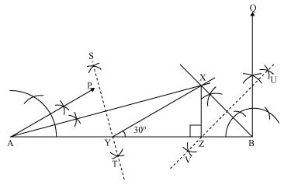

Solution 5

The steps of construction for the required triangles are as follows:  
**Step I:** Draw line segment AB of 12 cm. Draw a ray AX making 90o with AB.

**Step II:** Cut a line segment AD of 18 cm. (As sum of other two side is 18) from ray AX.

**Step III:** Join DB and make an angle DBY equal to ADB.

**Step IV:** Let BY intersects AX at C. Join AC, BC.http://images.topperlearning.com/topper/bookquestions/1093_ec7fd5b2b4109644a398eba4d25ebf00.pngABC is the required triangle.

